Fishing line Recovery Bin –2017 Bin Update (August-December)
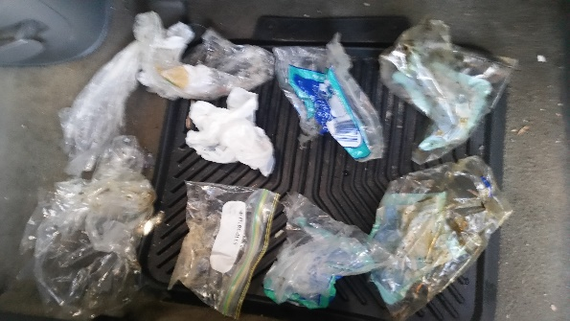
My three Fishing Line Recovery Bins which were placed at the following locations - Boyd’s Bay Bridge Tweed Heads, Old Barney’s Point Bridge Chinderah and Dry Dock RD Tweed Heads have been Audited since August of 2017. One of the bins which has been located at Chinderah wharf since the start of 2017.
These three bins have been a big success in eliminating a large amount of fishing line and related items such as plastic bait bags found in these areas. With further data recording and more bins placed in surrounding areas we should see an even bigger change in the number’s collected.
We plan to be replacing the current bins and adding additional bins in the new year to the bin style used on the Gold Coast as these are proven to more effective design. We have applied for a grant to assist us with the costs. Tweed Bait has also offered to purchase a further 5 bins. Redlands council is also going to assist in buying some bins in conjunction with us.

Bin | Fishing line(meter) | Lures | Hooks | Sinkers | Plastic Bag’s |  | Swivels | Other items
1.Boyds bay Bridge | 54.5 | 1 | 9 | 1 | 3 |  | 0 | 11
2. Dry dock | 93 | 0 | 8 | 3 | 33 |  | 1 | 16
3.Chinder Wharf | 164.5 | 0 | 6 | 2 | 8 |  | 2 | 3
Total | 312 | 1 | 23 | 6 |  | 44 | 3 | 30

Notes
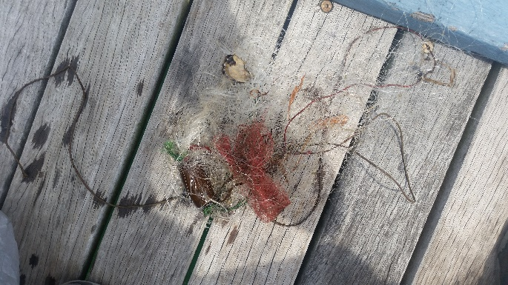
We have found that the bin at Boyd’s bay Bridge Bin has not been collecting the amount we first thought it would. We will be moving this bin to the wharf that is in the same area as were it was originally located. This is to increase the amount of fishing line collected.
This bin has since been stolen from boyds bay bridge around the end of December, this bin will hopefully be replaced mid-January 2018 with the new bin style. If we are unable to then we will place a temporary bin at the location.
We have found with the current style of bins, we were having problems with people stealing different parts of the bin as well as people tampering with the rubbish inside them so to limit this we have fitted them with a screw that only we can remove with a screw driver thanks to suggestions made by Lewis. We have also decided to drill holes in the bins to assist with drainage when heavy rain occurs as the bins were filling with water.
Again, thank you to Ann and Lewis in assisting in emptying the bins and Sylvia in making these bins possible.
Joshua Carpenter-Coordinator of Tweed Heads fishing line recovery bins
0437758740/ killercroc771@gmail.com

